**Weekly Activities Database**

# Project Team (3 students)

|  |  |  |
| --- | --- | --- |
| **No** | Stu-Number | Name Surname |
| 1 | 18070006042 | Tuğberk Göktepe |
| 2 | 18070006048 | Ekin Uygar Duman |
| 3 | 18070006003 | Yiğit Gökkaya |

**PHASE 4- USER INTERFACE (Due Jan, 10)**

# Graphical User Interface

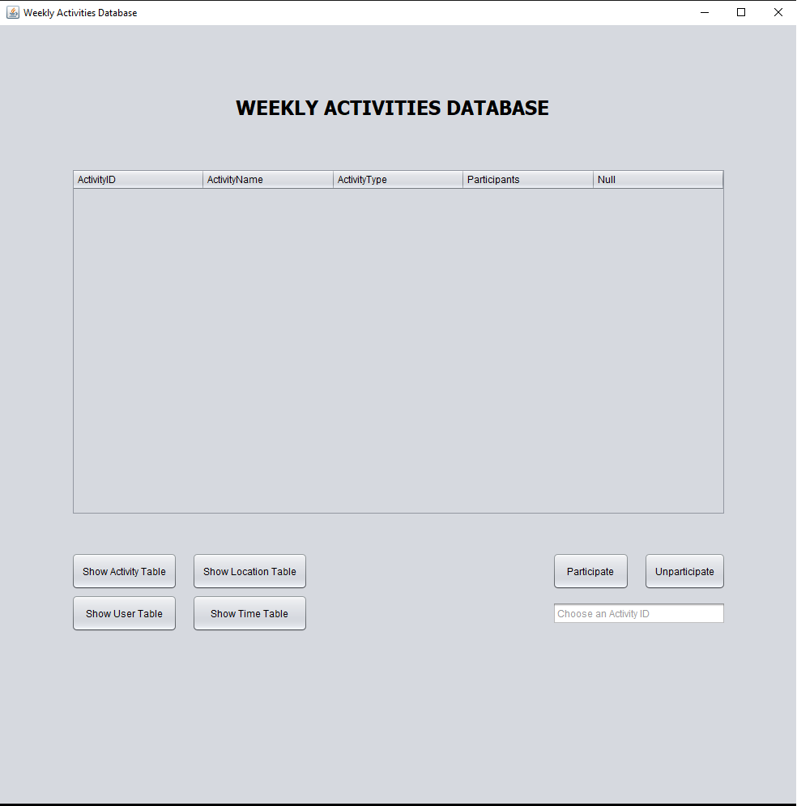

Here, you can see our GUI application.

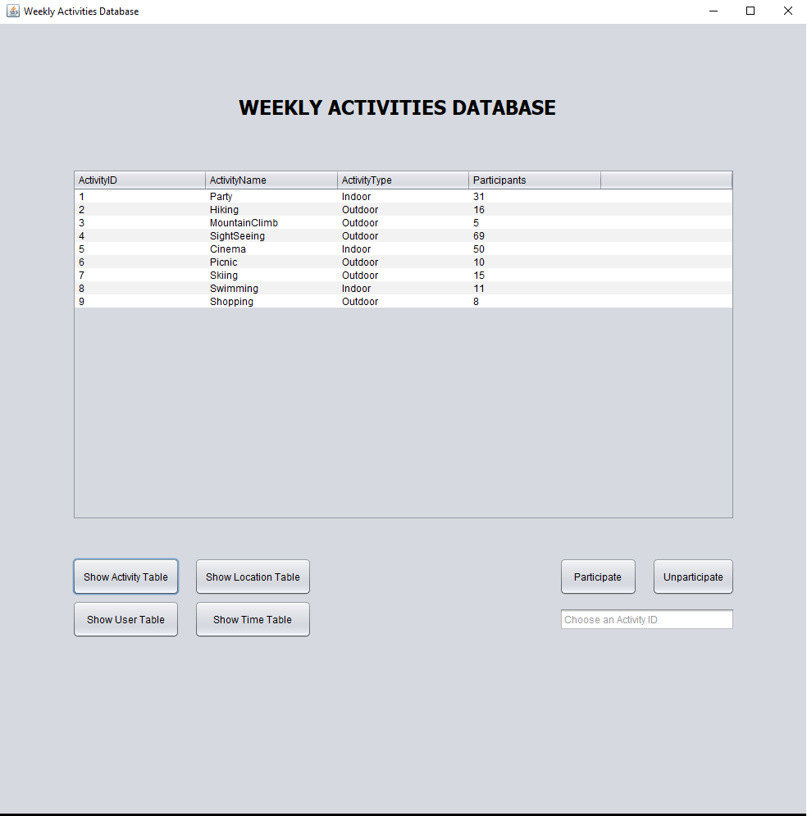

Here is the Activity Table.

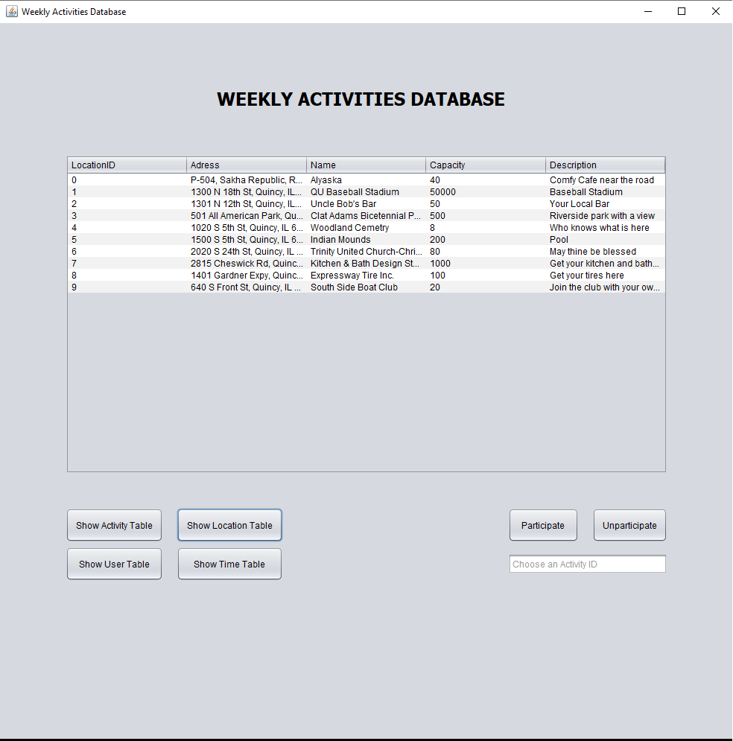

Here is the Location Table.

# Presentation

* Prepare a presentation for database, tables and relations with SQL examples---10 slides with a running application
* Be ready to answer immediate questions---for each team member 2 questions at least

# Discussion and self-evaluation

In this project our main goal was to achieve a nice and flexible weekly activities database. To achieve our goal, first we designed the database using ER diagrams. After we did the diagram, we created the tables and started inserting values to them. While doing this process, we tried to reach 3NF. After we were satisfied with the state of our database, we started to work on our GUI project.

Implementing the GUI was a bit difficult, but with enough determination and research we overcame it. Even though the application is fine, there are still some room for improvement such as:

-Adding a login system to keep track of users.

-Adding constraints to prevent infinite data manipulation.

To conclude, this project taught us many principles and it empowered our teamwork skills.

# Peer-Review ? (table filled) (???)

**Tuğberk Göktepe:**

This project improved my skill at designing Database and GUI tremendously. Because for even the smallest problem, I had to a minimum research of 10 minutes. We also improved our teamwork ability to a next level. Overall this project was fun and it is a huge jump for my career.

**Yiğit Gökkaya:**

While doing this project I learned how to connect working database app using Java. Since we worked as team this experience also gave me an insight about how my classmates think and implement this thought process into code. Since I will most likely to be working with a team when I get a job, this experience also improved my communication skills and made me feel more prepared for the future to come.

**Ekin Uygar Duman:**

Ekin Uygar Duman has learnt it is hard to make a good database and needs well thought and developed systems to have it working. I learnt how to use other programs with sql and have better knowledge of how to refine a database.